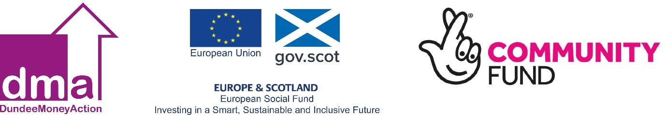

The impact of Covid-19 has left many of our Dundee Citizens without jobs, reduced hours and not forgetting self-employed people, who have all lost or have had income cut due to the closure of businesses across the country.

Are you worried about how you are going to pay bills or creditors and lenders?
Worried about debts?
Unsure if you are entitled to any welfare benefits or other grants?

DUNDEE MONEY ACTION IS HERE TO HELP YOU AND ITS FREE!

At present we are offering our usual bespoke service, with the support and advice provided over the phone and by email.

Call us on 01382431180 or email us info@dundeemoneyaction.org
WHO ARE WE?

We are a multi-partnership funded project, which includes Dundee City Council, Shelter, Citizens Advice Bureau, Brooksbank and Wise Group.

Once we receive your details you will be allocated your own personal Financial Support Officer who will contact you to introduce themselves – you will continue to be supported by them throughout your journey with Dundee Money Action.

Our friendly team have experience in helping people by working with them to develop an action plan, which can include a wide range of assistance such as
- a financial health check
- welfare benefits check and applications for benefit
- help to determine where income can be maximised
- support to negotiate reduced payments to organisations
- access to our fully trained debt advisors
- challenging welfare benefit decisions
- skills and knowledge development about financial products such as comparison sites, insurance, different bank accounts, savings, priority debts, credit ratings etc.
- fuel tariff checks, warm homes discount, applications for white goods - with our own energy advisor
- A dedicated Adult literacy/IT skills support worker
- and much more
They can also refer to other services out with DMA such as

Employability.  Housing Support | Mental health groups  Local social groups
The main aim at the end of the client’s journey with Dundee Money Action is for them to achieve long term outcomes, by completing their personal action plan and gaining financial knowledge, skills and confidence to deal with their money effectively in the future and to resolve debt issues.

Eligibility Criteria
- Live in Dundee  - Be of working age  - Have the legal right to live and work in the UK | Additionally meet one of the following  - Live in a Low Income Household  - Live in a household where no one is in work  - Live in a Lone Parent Household

