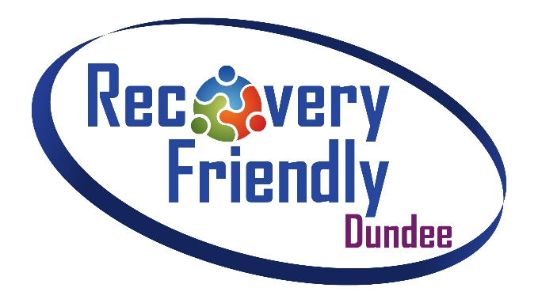

Your Pledge

RAISING AWARNESS | REDUCING STIGMA | SUPPORTING PEOPLE
Thank you for your interest in supporting Recovery Friendly Dundee

Recovery Friendly Dundee aims to support everyone’s recovery journey by raising awareness of wider issues surrounding substance use and tackle the stigma faced by people in recovery.

The Recovery Friendly Dundee Pledge demonstrates a self-commitment from groups and organisations which support the ethos and values of a Recovery Friendly Dundee.

If you would like more information or support to complete your pledge, please contact the Recovery Friendly Dundee representative in your area:

Emma Allan (Lochee & Strathmartine) – emma.allan01@dundeecity.gov.uk / 07584889448

Rhea Dryden (Coldside & Maryfield) – rhea.dryden@dundeecity.gov.uk / 01382 435838

Christine Dallas (North East & East End) – christine.dallas@dundeecity.gov.uk / 01382 432569

For all other areas, contact Robin Falconer – robin.falconer@dundeecity.gov.uk / 01382 435854

Your pledge is a commitment to the Recovery Friendly Dundee ethos as follows:

We believe that people should be treated with respect and dignity and that Dundee should be a city where everyone feels valued, respected and supported rather than defined by their health condition or life circumstances. Dundee should be a safe and supportive city and the efforts of people in recovery should be recognised and encouraged.

Your commitment may include:

- Attending an awareness session
- Treating everyone with dignity and respect
- Providing people with access to information and support
- Challenging negative attitudes and language that stigmatises people in recovery
- Building your awareness of what is available to support people in your area

To register your Pledge, please complete your details on the form below.

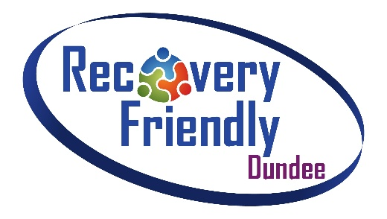
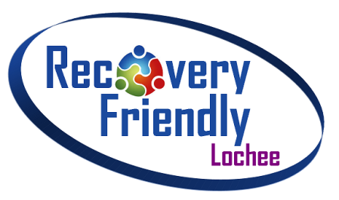
Your Pledge

RAISING AWARNESS | REDUCING STIGMA | SUPPORTING PEOPLE

Before completing this form, please ensure that you have read and understood the information above. This form should be completed and returned via the details stated at the end of the form. Please complete electronically or in BLOCK CAPITALS.

Name of group / organisation (As should appear on your certificate)

Name of main contact

Address

Tel. Number

E-mail address

Personal commitment (optional)
If your group/organisation would like to make a personal commitment please tell us here and we will include it on your certificate. (30 words max.)

Continued>

Continued>
Please tell us about any support you would benefit from in order to support your commitment to Recovery Friendly Dundee (we will try our best to help you with this)

Please complete the declaration and return along with your application

Declaration
On behalf of my group/organisation, I confirm our commitment to the Recovery Friendly Dundee ethos and our personal commitment (if provided) above.

PRINT NAME

/ /

Signature Date

Thank you for your application and for supporting the Recovery Friendly Dundee initiative

Once complete, please return to your Recovery Friendly Dundee representative named above.

Alternatively, print and return to:

Recovery Friendly Dundee
C/o Community Health Team – Room 21 Mitchell Street Centre – Mitchell Street Centre
Dundee, DD2 2LJ

We aim to issue pledge certificates within 1 week of receipt of your application

Supported by Dundee City Council, Dundee Health and Social Care Partnership and the voluntary sector

